Introduction
If you want to determine if there are any statistically significant differences between the means of two or more independent groups, you can use a one-way analysis of variance (ANOVA).
Assumptions
- Assumption #1: You have one dependent variable that is measured at the continuous level.
- Assumption #2: You have one independent variable that consists of three or more categorical, independent groups.
- Assumption #3: You should have independence of observations, which means that there is no relationship between the observations in each group of the independent variable or among the groups themselves.
- Assumption #4: There should be no significant outliers in the three or more groups of your independent variable in terms of the dependent variable.
- Assumption #5: Your dependent variable should be approximately normally distributed for each group of the independent variable.
- Assumption #6: You have homogeneity of variances (i.e., the variance of the dependent variable is equal in each group of your independent variable).
Null and alternative hypotheses
The null hypothesis for a one-way analysis of variance is:
H0: all group population means are equal (i.e., μ1 = μ2 = μ3 = ... = μk)
where μ = population mean and k = number of groups.
HA: at least one group population mean is different (i.e., they are not all equal)

Dataset and Problem
A plant study was conducted to evaluate the effect of two different treatment types on the dried weight of plants. A total of 30 plants were randomly assigned to one of three groups: a control group (ctrl), Treatment 1 (trt1), and Treatment 2 (trt2). The researcher would like to know if plant weight is dependent on the treatment group. Using variable terms, is the mean weight different for different levels of the group variable?
Checking of Assumptions
- Assumption #1: You have one dependent variable that is measured at the continuous level.
Remark. The dependent variable is weight (dried biomass), which is measured at the continuous level.
- Assumption #2: You have one independent variable that consists of three or more categorical, independent groups.
Remark. The independent variable is group, which is categorized into three independent groups: ctrl, trt1, and trt2.
- Assumption #3: You should have independence of observations, which means that there is no relationship between the observations in each group of the independent variable or among the groups themselves.
Remark. Each observation is independent, as there is no relationship between the plants in each group or between the groups themselves.
- Assumption #4: There should be no significant outliers in the three or more groups of your independent variable in terms of the dependent variable.
Remark. There were no significant outliers in the treatment groups in terms of plant weight, as assessed by visual inspection of boxplots.
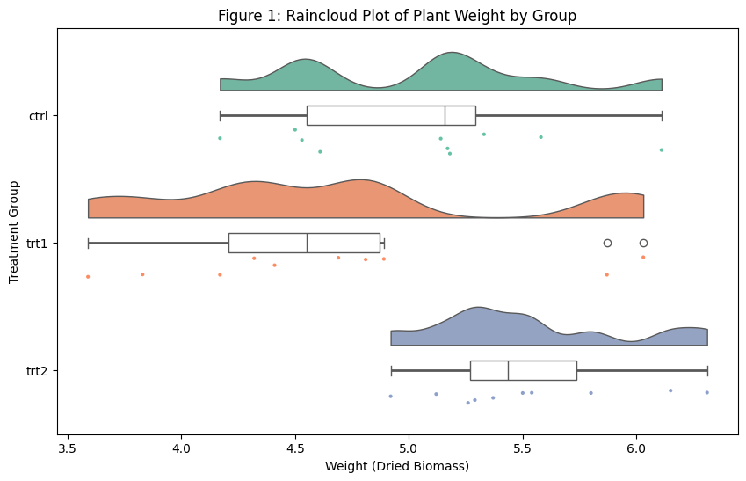
- Assumption #5: Your dependent variable should be approximately normally distributed for each group of the independent variable.
Remark. Normality was assessed using the Shapiro-Wilk test. The plant weight is approximately normally distributed for each of the groups, as p > 0.05.
--- Table 1: Descriptive Statistics ---
group count mean std
0 ctrl 10 5.032 0.583
1 trt1 10 4.661 0.794
2 trt2 10 5.526 0.443

--- Table 2: Normality Test---
W pval normal
group
ctrl 0.956681 0.747473 True
trt1 0.930411 0.451944 True
trt2 0.941005 0.564252 True
- Assumption #6: You have homogeneity of variances (i.e., the variance of the dependent variable is equal in each group of your independent variable).
Remark. Homogeneity of variances was assessed using Levene's test.
--- Table 3: Homogeneity of Variances ---
W pval equal_var
levene 1.119186 0.341227 True
There was homogeneity of variances, as assessed by Levene’s test, p = 0.341.
Computation
--- Table 4: One-Way ANOVA Results ---
Source SS DF MS F p_unc np2
0 group 3.7663 2 1.8832 4.8461 0.0159 0.2641
1 Within 10.4921 27 0.3886 NaN NaN NaN

--- Table 5: Tukey Post-hoc Analysis ---
A B mean_A mean_B diff se T p_tukey hedges
0 ctrl trt1 5.032 4.661 0.371 0.2788 1.3308 0.3909 0.5102
1 ctrl trt2 5.032 5.526 -0.494 0.2788 -1.7720 0.1980 -0.9140
2 trt1 trt2 4.661 5.526 -0.865 0.2788 -3.1028 0.0120 -1.2893

Reporting.
A one-way ANOVA was used here to determine if plant weight was different for groups with different treatment conditions. Participants were classified into three groups: control (sample size n = 10), treatment 1 (n = 10), and treatment 2 (n = 10). There were no outliers, which were determined by a visual inspection of a raincloud boxplot. The data were normally distributed for each group. This was assessed by a Shapiro-Wilk test, where p > .05. There was also homogeneity of variances, which was found by Levene's test (p = .341).
Data is presented as mean 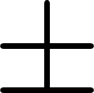 standard deviation. Plant weight was statistically significantly different between different treatment groups, F(2, 27) = 4.846, p = 0.016, 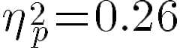. Plant weight increased from treatment 1 (M = 4.66, SD = 0.79) to the control group (M = 5.03, SD = 0.58) and treatment 2 (M = 5.53, SD = 0.44). Tukey post hoc analysis revealed that the mean increase from treatment 1 to treatment 2 (0.865, 95% CI [0.17, 1.56]) was statistically significant (p = 0.012), but no other group differences were statistically significant

